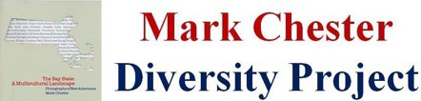

For Immediate Release June 1, 2022
Media Contact: Mark Chester markchester31@gmail.com ; www.markchesterphotography.com

Billerica Library is pleased to be sponsoring the exhibition, The Bay State: A Multicultural Landscape, Photographs of New Americans
from June 1 – June 30, 2022

The work of noted photographer Mark Chester, the exhibit celebrates Massachusetts newest citizens hailing from 190 countries around the globe!

Billerica, MA Billerica Library is pleased to be presenting the work of nationally known photographer Mark Chester. His traveling exhibit, The Bay State: A Multicultural Landscape – Photographs of New Americans, is on display from June 1 – June 30, 2022, at 15 Concord Road in Billerica, MA. It will be open during regular library hours.
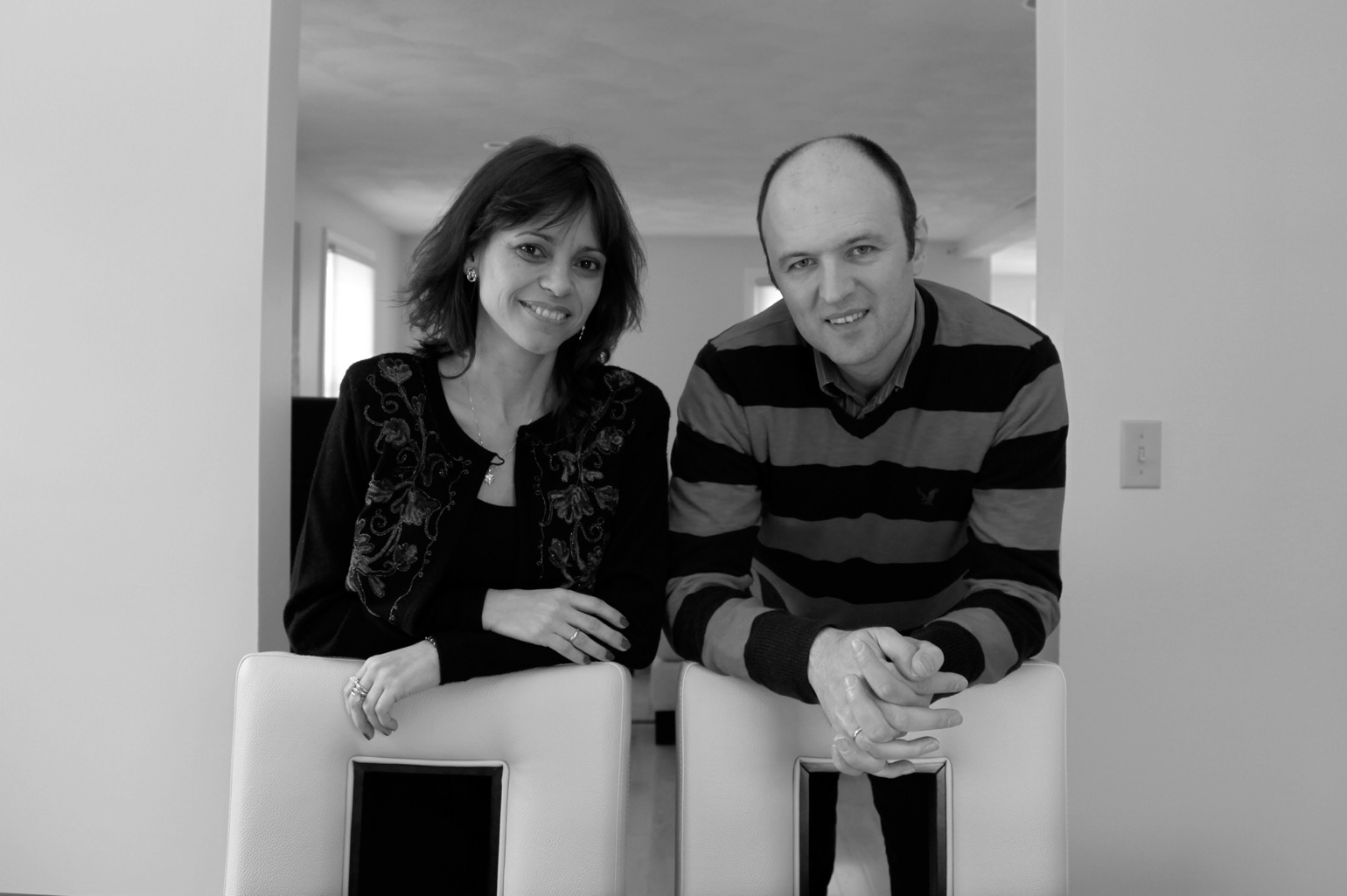
Bulgaria

Mark Chester’s powerful photographs showcase Massachusetts newest citizens, who hail from 190 countries and territories around the globe. Through Mark Chester’s lens, viewers can share and celebrate the vast ethnic heritage and rich cultural history of the Bay State’s 351 towns and cities.

Chester attended naturalization ceremonies across the state to personally meet some of the hundreds of individuals who have become America’s newest citizens and residents of the Bay State. Mark’s long career has taken him across the Globe, with photographs that have appeared in Time, and Newsweek among a host of other national publications. He was the photographer for Charles Kuralt’s book Dateline America. For further information, call the library at (978) 671-0948 or log on to www.billericalibrary.org

